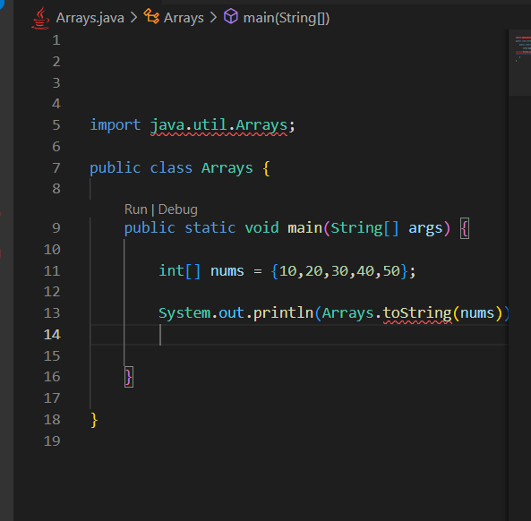

Here the name of file is Arrays.java

So the very first class is Also Arrays

And we see we could not use Arrays.toString() method



This error shows because we are defining our class as Arrays

And

We are also trying to import the Arrays class, which has predefined handy methods like Arrays.toString( )

So do not create a same class as the one we are importing

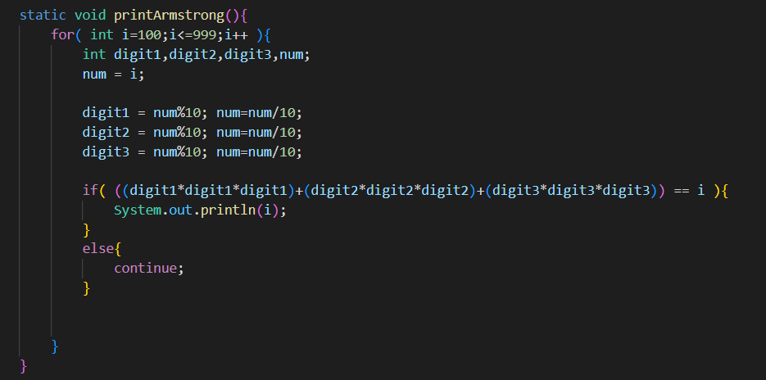

here in this code

in this line

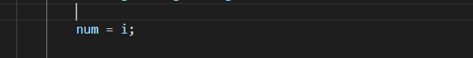

Here we must put value of I in some variable like num and work on that num throughout the loop

We must not never work on the “ i ” itself like

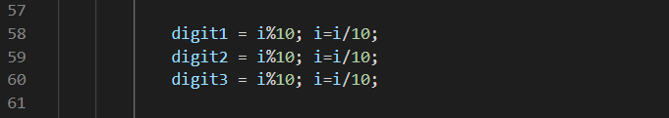

**It is really bad practice and causes error**